Speaker Series April – May 2024 Schedule
SRH University Heidelberg

Intercultural Competencies
In-classroom for students and Zoom: https://uiw.zoom.us/my/drteresalao
Meeting ID: 5163502491

Faculty, Staff, and Students are Invited!
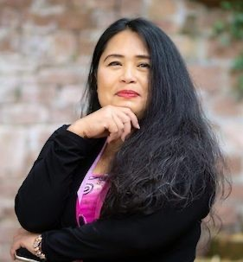
NOTE: All times are Central European Time (CET)

Visiting Professor: Teresa Lao, Ph.D., JD (Law), MA,
& Graduate Certificate in Project Management
Lecturing at SRH Intercultural Competencies


Mark Woodard, JD, MBA
Thursday, April 11 @ 11:30 am – In-person
Certified Arbitrator/Mediator, Muay Thai Coach

Mark Woodard has a Juris Doctor in Law from Purdue University, a Master of Business Administration with a specialization in Human Resources Management, and a Bachelor of Science in information technology. He is a United States Army veteran serving in duty stations in Germany, Saudi Arabia, Korea, and the United States. He has experience as an international speaker with speaking engagements in Argentina and Germany. For fun, he coaches Muay Thai for DominionMMA in San Antonio, TX, USA. He recent held Muay Thai classes for 162 students in Concepcion Del Uruguay, Argentina.


Pete Troillo
Real Estate Developer
Tuesday, April 16 @ 11:30 a.m. via Zoom

Mr. Troilo is a business strategy, risk management, and strategic communications professional with more than 15 years’ experience advising Fortune 50 companies, international development organizations, and the United States Government. He has sold, designed, and executed client projects across diverse subject areas, including global development policy and finance, corporate social responsibility and sustainability, public-private partnerships, enhanced due diligence and investigations, security and political risk, and post-conflict stabilization and reconstruction. Mr. Troilo is an expert on the business of global development, specifically how governments, international financial institutions, and private sector companies invest and operate in low- and middle-income countries. He has built and directed data collection, research, analytics, and reporting work teams in the Philippines for more than a decade and is a respected analyst of the country’s socio-political dynamics, development priorities and programs, and business environment. Mr. Troilo holds a Master's Degree from Georgetown University in Washington DC.

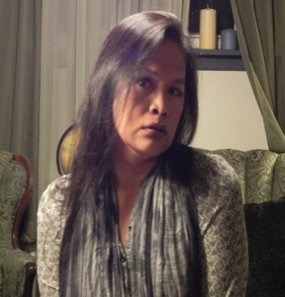
Nile C. Tiburan, PhD, RN, MS, NE-BC, CPHQ, CCRN, CMC, CEN
Director of Emergency Services
Wednesday, April 24, 2024 @ 1:30 pm

Dr. Tiburan goes by “she and her.” Her passion in life is ethnic and gender minority activism. She has spoken locally and internationally on clinical, organizational leadership and management, and diversity topics. She is currently the director of emergency services at Carondelet St. Joseph’s Hospital in Tucson, Arizona. She has conducted diversity, leadership, and clinical inquiries. She has taught in the nursing program at universities in the U.S. and the Philippines. She has held positions such as senior director of nursing, nurse educator and clinical nurse specialist. She is a staunch advocate for equality and inclusion in the workplace.

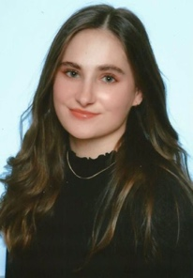
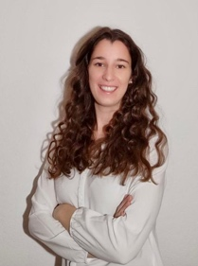
HANNAH MAUCH & DAPHNE KAUPE
Alumni of SRH Heidelberg and
The University of Incarnate Word
MA, SRH University
MBA Finance, The University of Incarnate Word
Tuesday, April 30 @ 11:30 am via Zoom

Daphne Kaupe and Hannah Mauch, both alumni of SRH Heidelberg, pursued their master’s degrees in business administration - International Management and Leadership. As a pivotal part of their academic journey, they embarked on the MBA program with a specialization in Finance at UIW in San Antonio, Texas. Immersed in this dynamic setting, they engaged with individuals from diverse cultural backgrounds, gaining profound insights into various workstyles and lifestyles within a different cultural context.

Prior to her master’s degree, Daphne Kaupe pursued studies in Business Administration & Psychology at the University of Koblenz, followed by professional experience at KPMG in Public Sector consulting. On the other hand, Hannah Mauch undertook a dual study program focused on Business Administration - Technical Management within an international mechanical engineering corporation. Presently, both have transitioned into their professional careers, with Daphne contributing her expertise in strategy consulting at MHP, a subsidiary of Porsche, while Hannah has embarked on her journey with PwC in the audit domain.

LIC. ANDREA HASSAN
Vice Rector of International Relations
Universidad del Concepcion de Uruguay, Argentina
Tuesday, May 2 @ 1:30 pm via Zoom

Born in the city of Concepción del Uruguay (Province of Entre Ríos), Argentina, at 18 years old, she decided to study International Relations, which is why she moved to Buenos Aires to complete her undergraduate academic training at the University of Salvador (USAL). Although she worked for several years in multinationals and embassies, the opportunity to return to her hometown in 2007 for a better quality of life made her discover her vocation at the university environment, when she entered the University of Concepción del Uruguay for request from the UCU's Rector (2009), to create the international relations area of the institution, until she became vice-rector for international relations. Additionally, she has trained in Law (subtracting 10 subjects to be a lawyer) and she just completed a Doctorate in Higher University Education, which is inter-institutional (Universidad Austral, Universidad Abierta Interamericana and Universidad Nacional de Río Negro).
Likewise, she continues to train in national and international spaces, such as the Conferences Latin American Education (in Brazil, Chile, Paraguay, etc.); the annual conference of the European Association for International Education (Scotland, Switzerland, Finland, etc.); The conference annual of the Association of International Educators (United States of America and Canada), the Brazilian Association for International Education (FAUBAI); and she has been a scholarship recipient of the International Visitor Leadership Program (IVLP), the main professional exchange program of the Department of State of the United States of America, which seeks to promote mutual understanding with other nations through training visits in the United States in universities, organizations, etc., carefully designed for foreign leaders in different fields of knowledge. It should be noted that the scholarship recipients of this program are nominated and elected annually by the staff of US embassies throughout the world. She has assisted in the construction of several articles and reports, actively collaborates with several universities; educational institutions; NGOs; governing bodies; Embassies; Consulates, etc.
She is Member of the Team of External Advisors of the Advisory Council of Universities of the Argentine Foreign Ministry; Member of the Technical Team of the International Relations Commission of the Council of Rectors of Private Universities (CRUP); She collaborates with the Ministry of Education of the Nation and provides technical assistance in matters of projects linked to the internationalization of higher education. She is president, mandate fulfilled of the Forum Argentine Institute for International Education (FAEI, made up of 40 public management universities and private). She is assistant to the Argentine University Education Chair, headed by Dr. Héctor César Sauret (in the Higher Education Teaching Staff). And she works as a technical assistant for the Network of Latin American and Caribbean Associations of Private Universities (REALCUP).

About DR. TERESA LAO, PhD, JD, MA, Graduate Certificate in Project Management

Dr. Teresa Lao was a Fulbright Specialist Recipient. She went to Concepcion del Uruguay, Argentina to help the Universidad de Concepcion del Uruguay University, Communications and Education Department, with their curriculum on Communications and Artificial Intelligence.

Dr. Lao has 28 years of teaching experience, taught courses in doctoral, masters, and undergraduate degree programs in various institutions. Dr. Lao has a Ph.D. in Education/Curriculum and Instruction with a specialization in Learning Technologies from New Mexico State University, a Juris Doctorate in General Law from Concord Law School of Purdue University Global, a Master of Arts degree in Public Relations/Journalism from Ball State University, and a Graduate Certificate in Project Management from Walden University. She has served/continues to work as a Subject Matter Expert/Curriculum Developer for various courses in the field business communications, public relations, education, dissertation, and learning technologies.

Dr. Lao is also a certified Mediator for the Bexar County Dispute Resolution Center in San Antonio, Texas, and certified Arbitrator for the Better Business Bureau National Programs where she arbitrates consumer-business cases dealing with contracts, Lemon Law disputes, and Class Action Settlements with vehicle owners and car manufacturers. Dr. Lao also serves as a Guest Lecturer at SRH University, Heidelberg, where she teaches Intercultural Competencies, Contemporary Management Principles, and Diversity Management.

